System Prerequisites for Enhanced Mode of Knowledge Forum

Windows Domain Account

Many schools will create a separate Windows domain for students, which may have limited access rights. Therefore, if KF fails to run, try using the Administrator account to run KF again. Remember to modify the student profile if the problem is identified associated with account access rights.

Java

Enhanced mode of KF is java based, so an appropriate J2SE Runtime Environment (JRE) must be installed to run the program. At the moment, JRE 6 Update 2 and above versions are running smoothly with KF (Download here: http://java.sun.com/javase/downloads/index.jsp).

Internet Explorer (IE)

(1) Popup blocker – Enable pop-up for the KF server at http://kf.cite.hku.hk, or Simply disable the pop-up blocker

Enable pop-up for the KF server Open IE → Select “Internet Options” in the “Tools” pull-down menu → Switch to the “Privacy” tab → Click “Settings” in the “Pop-up Blocker” section → Type “http://kf.cite.hku.hk” in the box for “Address of Web site to allow” → Click “Add” to add the URL to the list of Allowed Sites

Disable pop-up blocker Open IE → Select “Internet Options” in the “Tools” pull-down menu → Switch to the “Privacy” tab → Unselect “Block pop-ups” in the “Pop-up Blocker” section

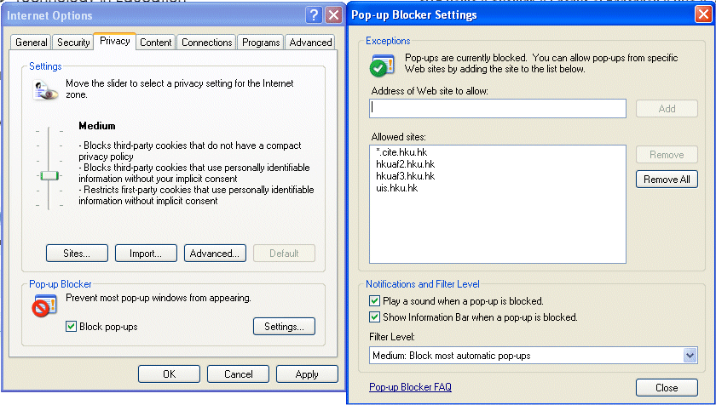

(2) Java applet – Enable your browser to run signed java applet, and Ensure your browser will check the certificate as well

Enable to run signed java applet Open IE → Select “Internet Options” in the “Tools” pull-down menu → Switch to the “Security” tab → Click “Custom Level” → Select “Enable” for “Scripting of Java applets”

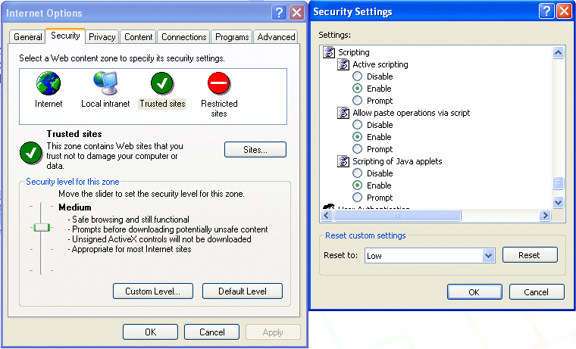

Ensure to check the certificate Open IE → Select “Internet Options” in the “Tools” pull-down menu → Switch to the “Advanced” tab → Select “Check for signatures of downloaded programs” for “Security”

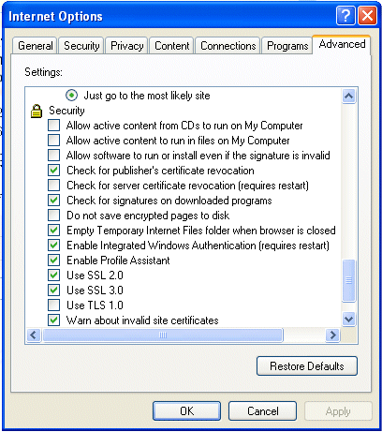
(3) Download file – Enable your browser to download files

Enable to download files Open IE → Select “Internet Options” in the “Tools” pull-down menu → Switch to the “Security” tab → Click “Custom Level” → Select “Enable” for “File download”

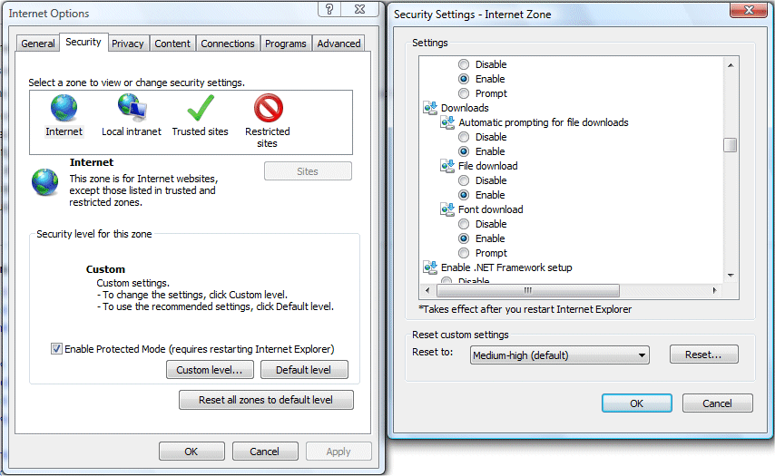

(4) Java – Enable your browser to run J2SE JRE and Java add-ons

Enable to run Java Open IE → Select “Internet Options” in the “Tools” pull-down menu → Switch to the “Advanced” tab → Select “Use JRE for <applet>” for “Java(Sun)”

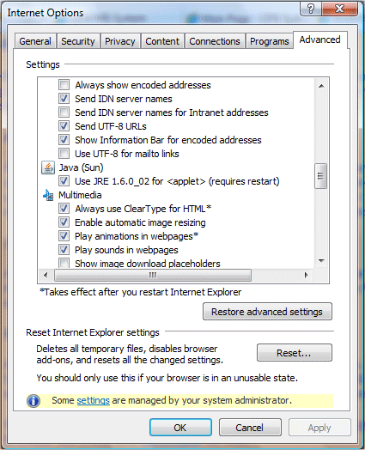
* If digital signature warning appears, click “Run” to allow KF to execute.
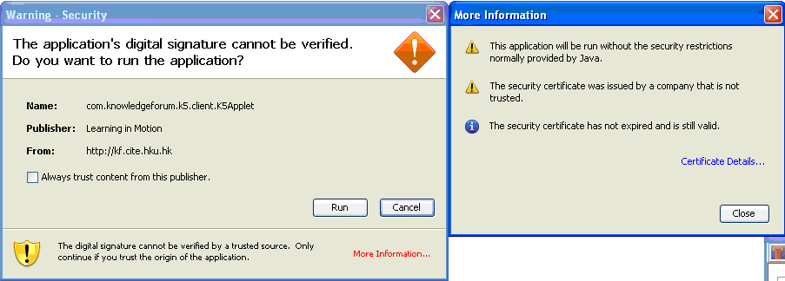

Proxy

Some schools may connect their web access to the network using Proxy server but it is recommended to remove the proxy server setting on IE. If it cannot be overridden, then add a rule to bypass the KF server at kf.cite.hku.hk.

Remove proxy server setting Open IE → Select “Internet Options” in the “Tools” pull-down menu → Switch to the “Connections” tab → Click “LAN Settings” in the “Local Area Network(LAN) settings” section → Unselect “Use a proxy server for your LAN” in the “Proxy server” section

Add a rule to bypass the KF server Open IE → Select “Internet Options” in the “Tools” pull-down menu → Switch to the “Connections” tab → Click “LAN Settings” in the “Local Area Network(LAN) settings” section → Type “kf.cite.hku.hk” in the box for “Address” and Select “Bypass proxy server for local address” in the “Proxy server” section → Click “OK” when you have finished

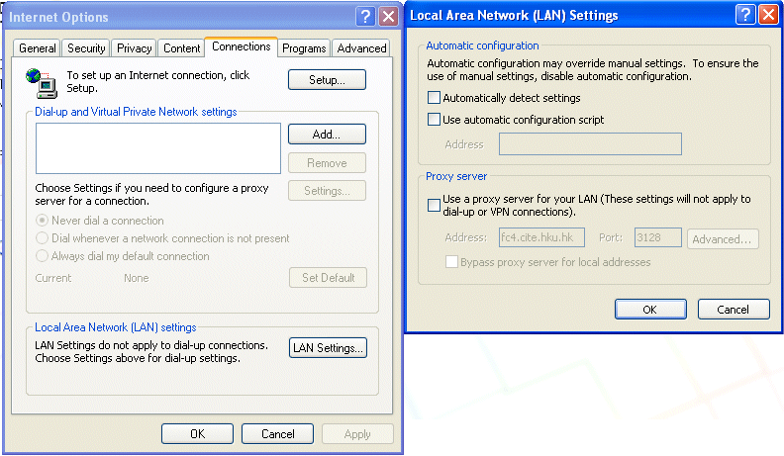

Firewall

If there is a firewall on your network, make sure KF server is not blocked by the firewall or open outgoing ruleset to our server host (kf.cite.hku.hk) at port 80 and port 8082.

