An Easy Guide to

Knowledge Forum 4.7 (Enhanced)

Overview
Knowledge Forum (KF) is an online environment for multiple users’ discussions. It is better than traditional newsgroup discussion because its features help writers to develop their ideas.

1. The Login Page
Type the URL in your browser: http://kf.cite.hku.hk/


Language Option
Databases
User Interface Option

Choose a database
Before you type in the username and password, you need to first choose the correct database to enter.
Select KBTN-Teachers2 database.

Choose a language
You can choose which language to work with.

Choose the UI Mode (User Interface Mode)
Select Enhanced for UI Mode (User Interface Mode).

Login Username & Password
Username(password): guest01(guest01)……guest60(guest60)

If you have any problem on logging into the database, please contact kbtn-info@cite.hku.hk.

2. Toolbar - The Icons

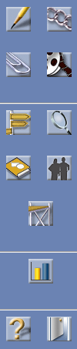
New Note
To create a new note

Assessment Tools
To access third party applets
Search
To search the database
Logout
To exit Knowledge Forum
View Finder
To find or create a view database
My Reader
To access My Reader
Help
To get online help
Authors
To view, add, or edit authors, groups and registration codes
New Attachment
To add an attachment to a view

New View Link
To add a view link to a view
New Movie
To add a movie to a view
Scaffolds
To view, add, or edit scaffolds

3. To post a note

To post a new note:
Click the “New Note” icon on the toolbar.

Understanding the components of a note
In Knowledge Forum, a Note is like a piece of paper that you can read or write on it. In addition, these notes have special features that help you to write down your ideas systematically.

Below is what a Note window looks like.

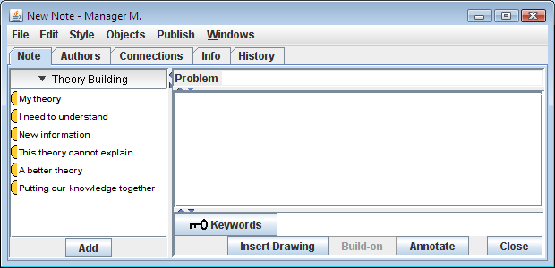
Note Content Box
Scaffolds
Keyword
Note Title
Annotation
Problem
Scaffolds: The structure that guides the writer to write down his/her ideas. Also, it lets readers know what the text is talking about.
Problem: The main theme of the note
Content: The things that the writer of that note wants to say
Keywords: Keywords or important ideas that are related to the topic

- Write the problem that is the theme of your note.
- Click on the scaffold that best suits your needs then click the button.
  - My theory – Your views, conjectures, explanations, etc.
  - I need to understand – Generate questions to help you learn – Question-asking and problem formulation is critical in problem solving
  - New information – Information from books, articles, websites that may help address the questions
  - A better theory – Pose a different viewpoint or a different explanation
  - Putting our knowledge together – You make a summary of different ideas from the notes
- Type your information inside the note content box and add more scaffolds to indicate your many ideas.
- Then, write the keywords that appeared in your message in the keyword box.
- Then click the button.
- You will be prompted for a title for the note.
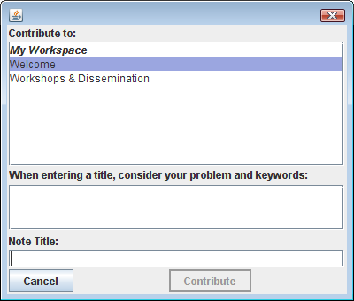
- Then click the button.

To build-on to someone’s note:
- Click to open the note that you want to build-on to.
- Click the button to open a new note that is linked to the original note.
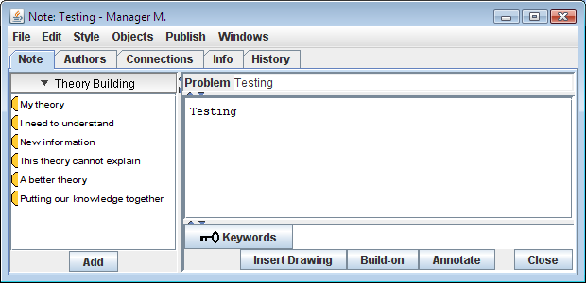
- A New Note window will pop out. Follow steps 1-6 for creating a new note to make your response.

To quote part of a note:
- Open the referenced note.
- Copy the text you want to reference.
- Paste the copied text into the note content box of the referencing note.
- Click the button after you have finished all.

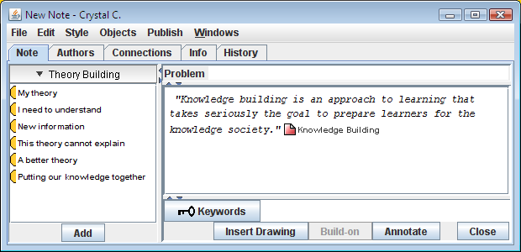
Copied text

To delete a note (with caution):
Sometimes you may want to delete your note after you have posted it. Do it only if it is absolutely necessary, for example, the note is useless. In KF, you can only delete your own notes.

- First of all, select the note that you want to delete.
- Click on the Edit menu and choose Clear or Delete.
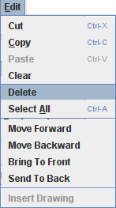
Clear – The note will disappear from the view.
Delete – The note will be deleted permanently.

To use the ‘Rise-above’ function:

Rise-above function allows writer to write an idea that 'rises above' the previous thinking and to store the relevant notes in a collection. Rise-above note is more than a folder which contains all the relevant notes.

To make an accurate rise-above note, you also have to wrap up the discussion, write a summary for it and also to lead to a new direction for your work. The Notes in the Rise-Above folder will disappear visually from the View after you have done the rise-above and become accessible only through the new Rise-Above Note.

To make rise-above note:

- First of all, select the notes that you want to do a rise above with. (Press “Shift” and left-click mouse at the same time to select a note.)
- Click on the Objects menu and choose Rise-Above.
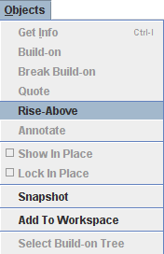

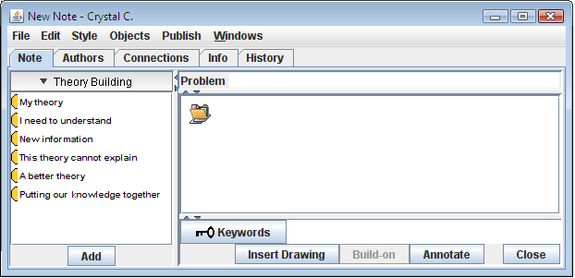
Rise-Above folder
- Input the note content like a normal note.
- Click the button after you have finished all.

4. Workspace

The Workspace in Knowledge Forum 4.7 acts as a temporary storage area for collecting related notes, attachments, movies, and views from multiple sources. You can work with Workspace as you would work with objects listed in a view or your search results.

You can open objects, create a rise-above note, create a reference note, and copy objects to another view from Workspace.

To go to Workspace, click.

To add to Workspace:

- Select the notes, views or attachments that you want to add to Workspace.
- Click on the Objects menu and choose Add to Workspace.
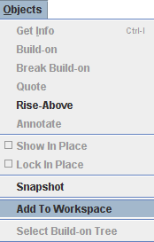
- The Workspace window pops up and objects will be copied to the window.
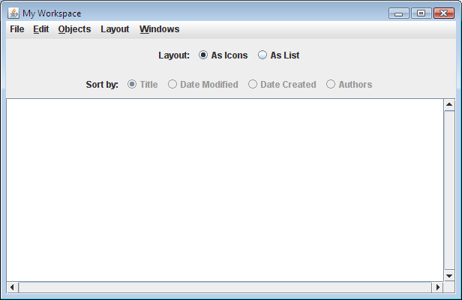
- You can sort the order of the notes by selecting “As List”.

5. Drawings

The Palette button  shows and hides the drawing palette 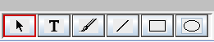. Use this palette to create a drawing in a view or a note.

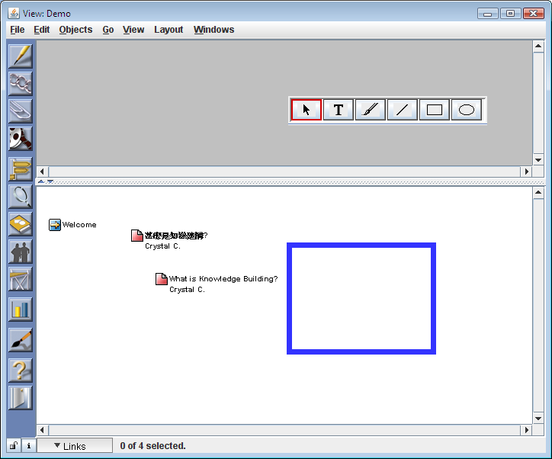

You can also drag and drop JPG, PNG or GIF format pictures from your desktop to a view or a note, then just click on the Object menu to select Show in Place.
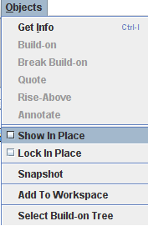

6. Search

You can search the database for notes and objects that fits your criteria, for example author, keyword, title and so on.

Click on the button to open the Search window.
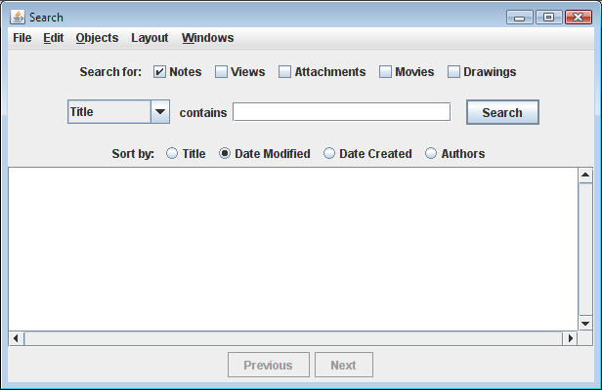

- Select the appropriate search criteria by the pull-down menu.
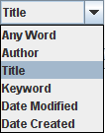
- Press to submit the search.

7. Components of a View

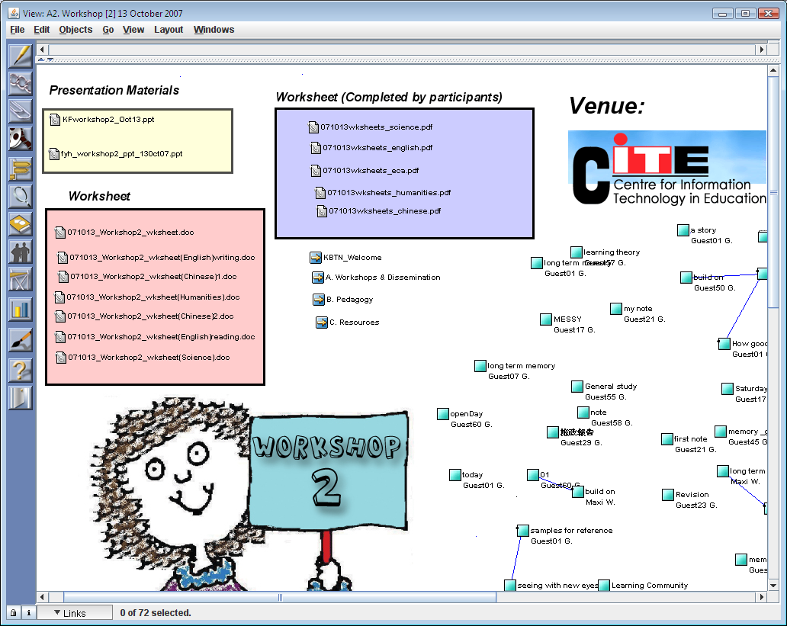
Toolbar
View Links

Notes
View Title
Attachments

